POC DESIGN DOCUMENT

For a smart cup on a bottle.

FEBRUARY 22, 2022

TECHY8

# Introduction

This document specifies key conceptual design for a smart pill cup, proof of concept design. The smart cup will be able to provide features such as: keeping track of the cup opening/closing, fingerprint reader, dosage trackage, content counter of the pills inside the bottle to which it is attached, and bottle location signaling; all provided to a website or a mobile application.

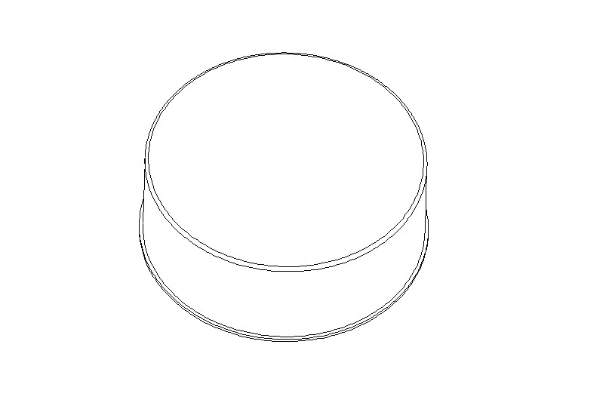

*Figure 1 : POC cup*

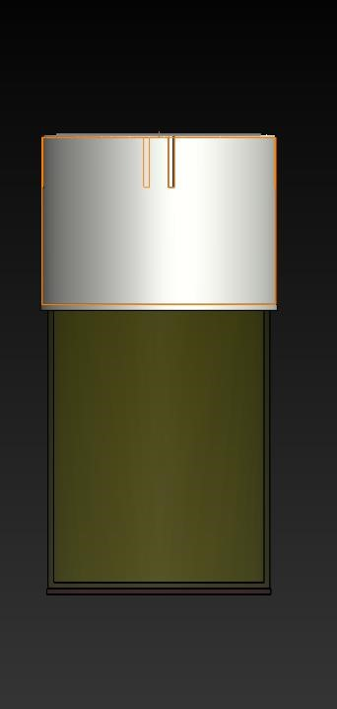

*Figure 2 Cup on bottle*

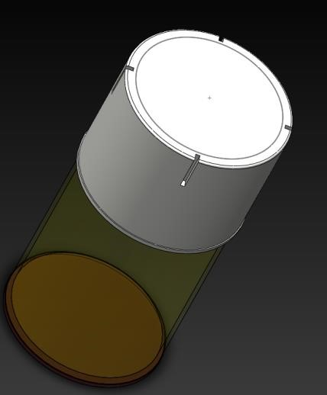

*Figure 3 Cap and bottle (view)*

## Tracking Cap Opening

A trigger switch placed on the cup will be able to detect when the bottles’ cup is opened or closed. The cup can only be opened if the fingerprint has successfully identified the owner or patient to whom the bottle belongs to.

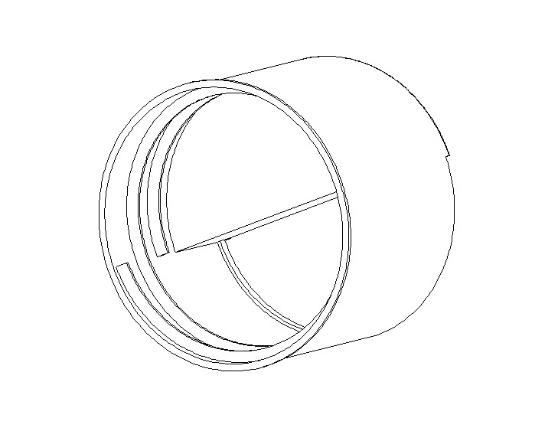

C

ont

act

switch

*Figure 4 : Cup thread*

## Finger print recognition

The finger print sensor, placed upon the cup will be able to identify the cap owner and that only, after the biometrical data has been retrieved and assured to be genuine, then a signal will be released by an imbedded microcontroller that will enable the locking mechanism of the bottle to be opened.

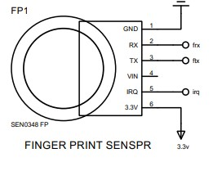

*Figure 5 Finger print sensor*

Programmable biometrics lock on the cap will prevent anyone other than the User to open the bottle.

## Track Dosage

Depending of the dosage set by the physician, a reminder will be provided from the handled phone so as to know exactly when to take the medicine, the last time it was taken and the next time it is supposed to.

## Content Counter

The counter will enable the User to know how much content has remained in the bottle and how many have been taken out.

A pressure sensor detects the amount of pressure applied to it, and the processing is done using the embedded microcontroller and that data is then shared with the phone so as to notify the user how many pills have remained in the bottle.

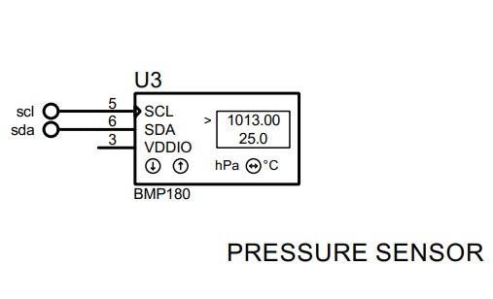

*Figure 6 force/ pressure/ weight sensor*

## Bottle Locating Signal Bottle

Locating signal to enable the User to locate their pills bottle should they forget or misplaced it. With the bottle allocating Single, a buzzer or a micro-speaker could be powered on and output a signal which will be triggered from the handled phone.

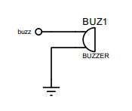

*Figure 7 Buzzer / speaker for bottle signaling the location*

## Sync to the Mobile App

via WIFI module through the microcontroller, all the data described above will be sent to the cold, and then from there, the data will be retrieved by the mobile phone or a personal computer.

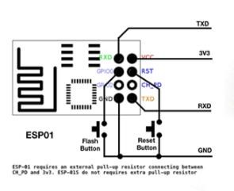

*Figure 8 WIFI module to send data in the server/cloud*

## Schematic diagram

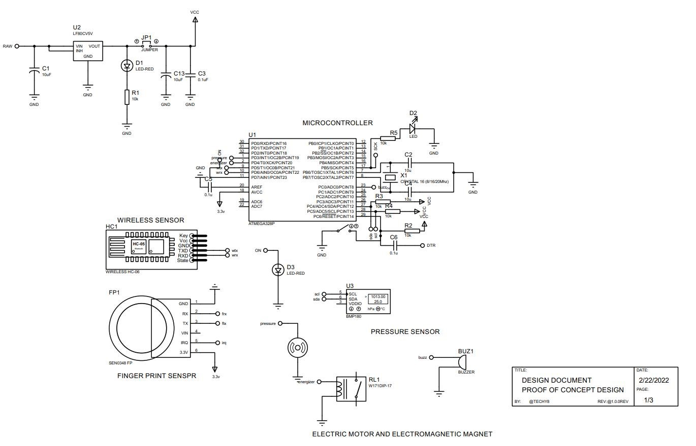

*Figure 9 Schematic diagram*

**Note**: The life span of the battery usually depends upon the devices to which it’s connected to. For the case of this POC design, much is still under development and different parameters are being looked up to set and to know how long could the battery truly last. Development is being conducted, and once enough is known about this feature, a report will be issued. But as a test and battery efficiencies are being conducted.

We are optimistic, trustful and sure; we will achieve the best results. When it comes to the bulkiness of the cup, this will greatly differ with the production product. This design will be huge due to the number of different boards used. But as soon as we will be heading to production, the size will greatly be reduced due to most/all components being on a single circuit board.

## Components ordered with respective features

|  |  |
| --- | --- |
| **Components** | **Feature** |
| **Capacitive finger print sensor** | Biometric finger print recognition |
| **Capacitive pressure/force sensor** | For weighting the content of the bottle and understand how many are there |
| **AtMega microcontroller** | For processing sensor data and sending information to the cloud |
| **WIFI module esp8266** | internet module used to send data to the cloud so as to help phone and device synchronization. |
| **Electronics components such as diode, led, resistors and wiring etc.…** | Help in interfacing sensors such as finger print sensor with the power and microcontroller |
| **Weight sensor** | Helps in measuring the number of pills due to individual weights. |
| **Breadboard** | Used to connect components during POC development. |
| **Contact switch sensor** | To understand, by using the microcontroller, when a cap is opened or closed. |